SAFEGUARDING CHILDREN AND ADULTS’ POLICY
Rare Autoinflammatory Conditions Community - UK (RACC - UK)
2019
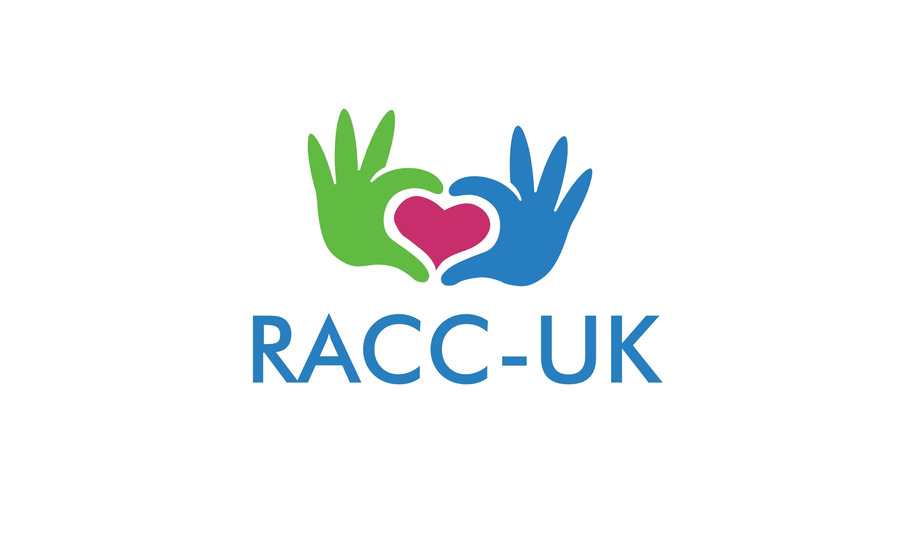
This policy applies to all staff, including senior managers and the board of trustees, paid staff, volunteers and sessional workers, students or anyone working on behalf of RACC - UK. This policy also applies to patients and their families.

The purpose of this policy:

• To protect all adults, children and young people who receive RACC - UK’s services;

• To provide staff and volunteers with the overarching principles that guide our approach to safeguarding adults and child protection; RACC - UK believes that an adult, child or young person should never experience abuse of any kind.

We have a responsibility to promote the welfare of all adults, children and young people and to keep them safe. We are committed to practise in a way that protects them.

Legal Framework

This policy has been drawn up based on law and guidance that seeks to protect adults and children, namely:

Children:
- The Care Act 2014 (http://www.legislation.gov.uk/ukpga/2014/23/contents/enacted)
- Children Act 1989 (http://www.legislation.gov.uk/ukpga/1989/41/contents)
- United Convention on the Rights of the Child 1989 (https://downloads.unicef.org.uk/wp-content/uploads/2010/05/UNCRC_united_nations_convention_on_the_rights_of_the_child.pdf?_ga=2.124909263.499314598.1573566282-1354666737.1573566282)
- Data Protection Act 2018 (http://www.legislation.gov.uk/ukpga/2018/12/contents/enacted)
- Human Rights Act 1998 (http://www.legislation.gov.uk/ukpga/1998/42/contents)
- Sexual Offences Act 2003 (https://www.legislation.gov.uk/ukpga/2003/42/contents)
- Children Act 2004 (http://www.legislation.gov.uk/ukpga/2004/31/contents)
- Protection of Freedoms Act 2012 (http://www.legislation.gov.uk/ukpga/2012/9/contents/enacted)
- Children and Families Act 2014 (http://www.legislation.gov.uk/ukpga/2014/6/contents/enacted)
- GDPR - General Data Protection Regulation 2018 with data protection at 2018 (https://www.which.co.uk/consumer-rights/regulation/general-data-protection-regulation-gdpr)
- Special Educational Needs and Disability (SEND) Code of Practice: 0 to 25 years- Statutory guidance for organisations which work with and support children and young people who have special educational needs or disabilities; HM Government 2014 (https://www.gov.uk/government/publications/send-code-of-practice-0-to-25)
- Information sharing: Advice for practitioners providing safeguarding services to vulnerable children, young people, parents and carers; HM Government 2015 (https://www.gov.uk/government/publications/safeguarding-practitioners-information-sharing-advice)
- Working together to safeguard children: a guide to inter- agency working to safeguard and promote the welfare of children: HM Government 2018 (https://assets.publishing.service.gov.uk/government/uploads/system/uploads/attachment_data/file/779401/Working_Together_to_Safeguard-Children.pdf.)

Adults:
- The Care Act 2014 (http://www.legislation.gov.uk/ukpga/2014/23/contents/enacted)
- Data Protection Act 2018 (http://www.legislation.gov.uk/ukpga/2018/12/contents/enacted)
- GDPR - General Data Protection Regulation 2018 with data protection at 2018 (https://www.which.co.uk/consumer-rights/regulation/general-data-protection-regulation-gdpr)
- Human Rights Act 1998 (http://www.legislation.gov.uk/ukpga/1998/42/contents)
- Sexual Offences Act 2003 (https://www.legislation.gov.uk/ukpga/2003/42/contents)
- Mental Health Act 2007 (http://www.legislation.gov.uk/ukpga/2007/12/contents)
- Safeguarding Vulnerable Groups Act 2006 (https://www.gov.uk/government/publications/safeguarding-policy-protecting-vulnerable-adults)
- Protection of Freedoms Act 2012 (http://www.legislation.gov.uk/ukpga/2012/9/contents/enacted)

This Safeguarding Policy should be read alongside our policies and procedures on:
• Equal Opportunities
• Social Media policy
• Complaints and Compliments Policy
• Whistleblowing
• Privacy Policy
• Code of Conduct and Ethics (ERN RITA 2019,
• Safer Recruitment Policy

We recognise that:

• The welfare of the vulnerable adult is paramount, as identified in the Care Act 2014.
• The welfare of the child is paramount, as identified in the Children Act 1989.
• All adults and children, regardless of their age, disability, gender, racial heritage, religious belief, sexual orientation or identity, have a right to equal protection from all types of harm or abuse.
• Some adults and children are additionally vulnerable because of the impact of previous experiences, their level of dependency, communication needs and other issues.
• Working in partnership with adults, children, young people, their parents, carers and other agencies is essential in promoting young people’s welfare.

We will seek to keep adults, children and young people safe by:
• Valuing them, listening to and respecting them
• Appointing a Designated Safeguarding Officer (DSO) for children and young people, a deputy and a lead board member for safeguarding.
• Adopting child protection and safeguarding practices through procedures and a code of conduct for staff and volunteers.
• Developing and implementing an effective e-safety policy and related procedures.
• Providing effective management for staff and volunteers through supervision, support, training and quality assurance measures.
• Recruiting staff and volunteers safely, ensuring all necessary checks are made. All staff and volunteers have a clear DBS.
• Recording and storing information professionally and securely and sharing information about safeguarding and good practice with children, their families, staff and volunteers via training, leaflets and posters.
• Using our safeguarding procedures to share concerns and relevant information with agencies who need to know, and involving children, young people, parents, families and carers appropriately.
• Using our procedures to manage any allegations against staff and volunteers appropriately and efficiently.
• Creating and maintaining an anti- bullying environment and ensuring that we have a policy and procedure to help us deal effectively with any bullying that does arise.
• Ensuring that we have effective complaints and whistleblowing measures in place and open to all staff, volunteers and members.
• Ensuring that we provide a safe physical environment for our adults, children and young people, staff and volunteers, by applying health and safety measures in accordance with the law and regulatory guidance.

In any situation where staff/ volunteers have face to face contact with patients and families:

- Staff / Volunteers must take care not to place themselves in a vulnerable position.
- It is advisable that any face to face contact with individual children or families is to be conducted in view of other adults.
- In a hospital setting, children and vulnerable adults would also be around healthcare professionals who also have safeguarding training and procedures in place.
- Patients and families will not attend the property in which the organisation is registered for insurance purposes. This is to protect themselves and staff / volunteers alike.
- Where possible, staff / volunteers should not be left with children on their own, except for in a public space e.g. if a parent asks if you can look after their child while they go to the toilet.

Disclaimer: Staff / Volunteers alike are not responsible for any contact between families outside of the organisations communication channels e.g. the private Facebook group or website forum. When communicating with families via social media, staff / volunteers should use the organisation’s accounts only in order to protect themselves and others.

In addition to the above points, staff and volunteers will also be required to agree and sign this policy before carrying out any work directly with patients and families. They will also be given a copy of the Charity Ethical Principles (January 2019) from the National Council for Voluntary Organisations.

Where allegations against a member of staff / volunteer in relation to the children and families supported by RACC - UK, then the designated safeguarding officer’s role would be to contact:
Alison Beasley - Interim Designated Officer (LADO)
Email: LADO.SafeguardingChildren@Oxfordshire.gov.uk
Tel: 01865 810603

Contact details: RACC - UK’s Designated Safeguarding Officer (DSO)
Name: Anna Davies
Email: support@raccuk.com
Address: Flat 1, 24 Swan Street, Eynsham, Witney, West Oxfordshire, OX29 4HU
Phone Number: (+44) 07377091552

CEOP https://www.ceop.police.uk/safety-centre/

NSPCC Helpline: 0808 800 5000

We are committed to reviewing our policy and good practice as our organisation develops.

This policy was last reviewed on: November 2019

AGREED AND SIGNED BY:

PRINT NAME:

POSITION:

AGREED AND SIGNED BY:

PRINT NAME:

POSITION:

AGREED AND SIGNED BY:

PRINT NAME:

POSITION:

